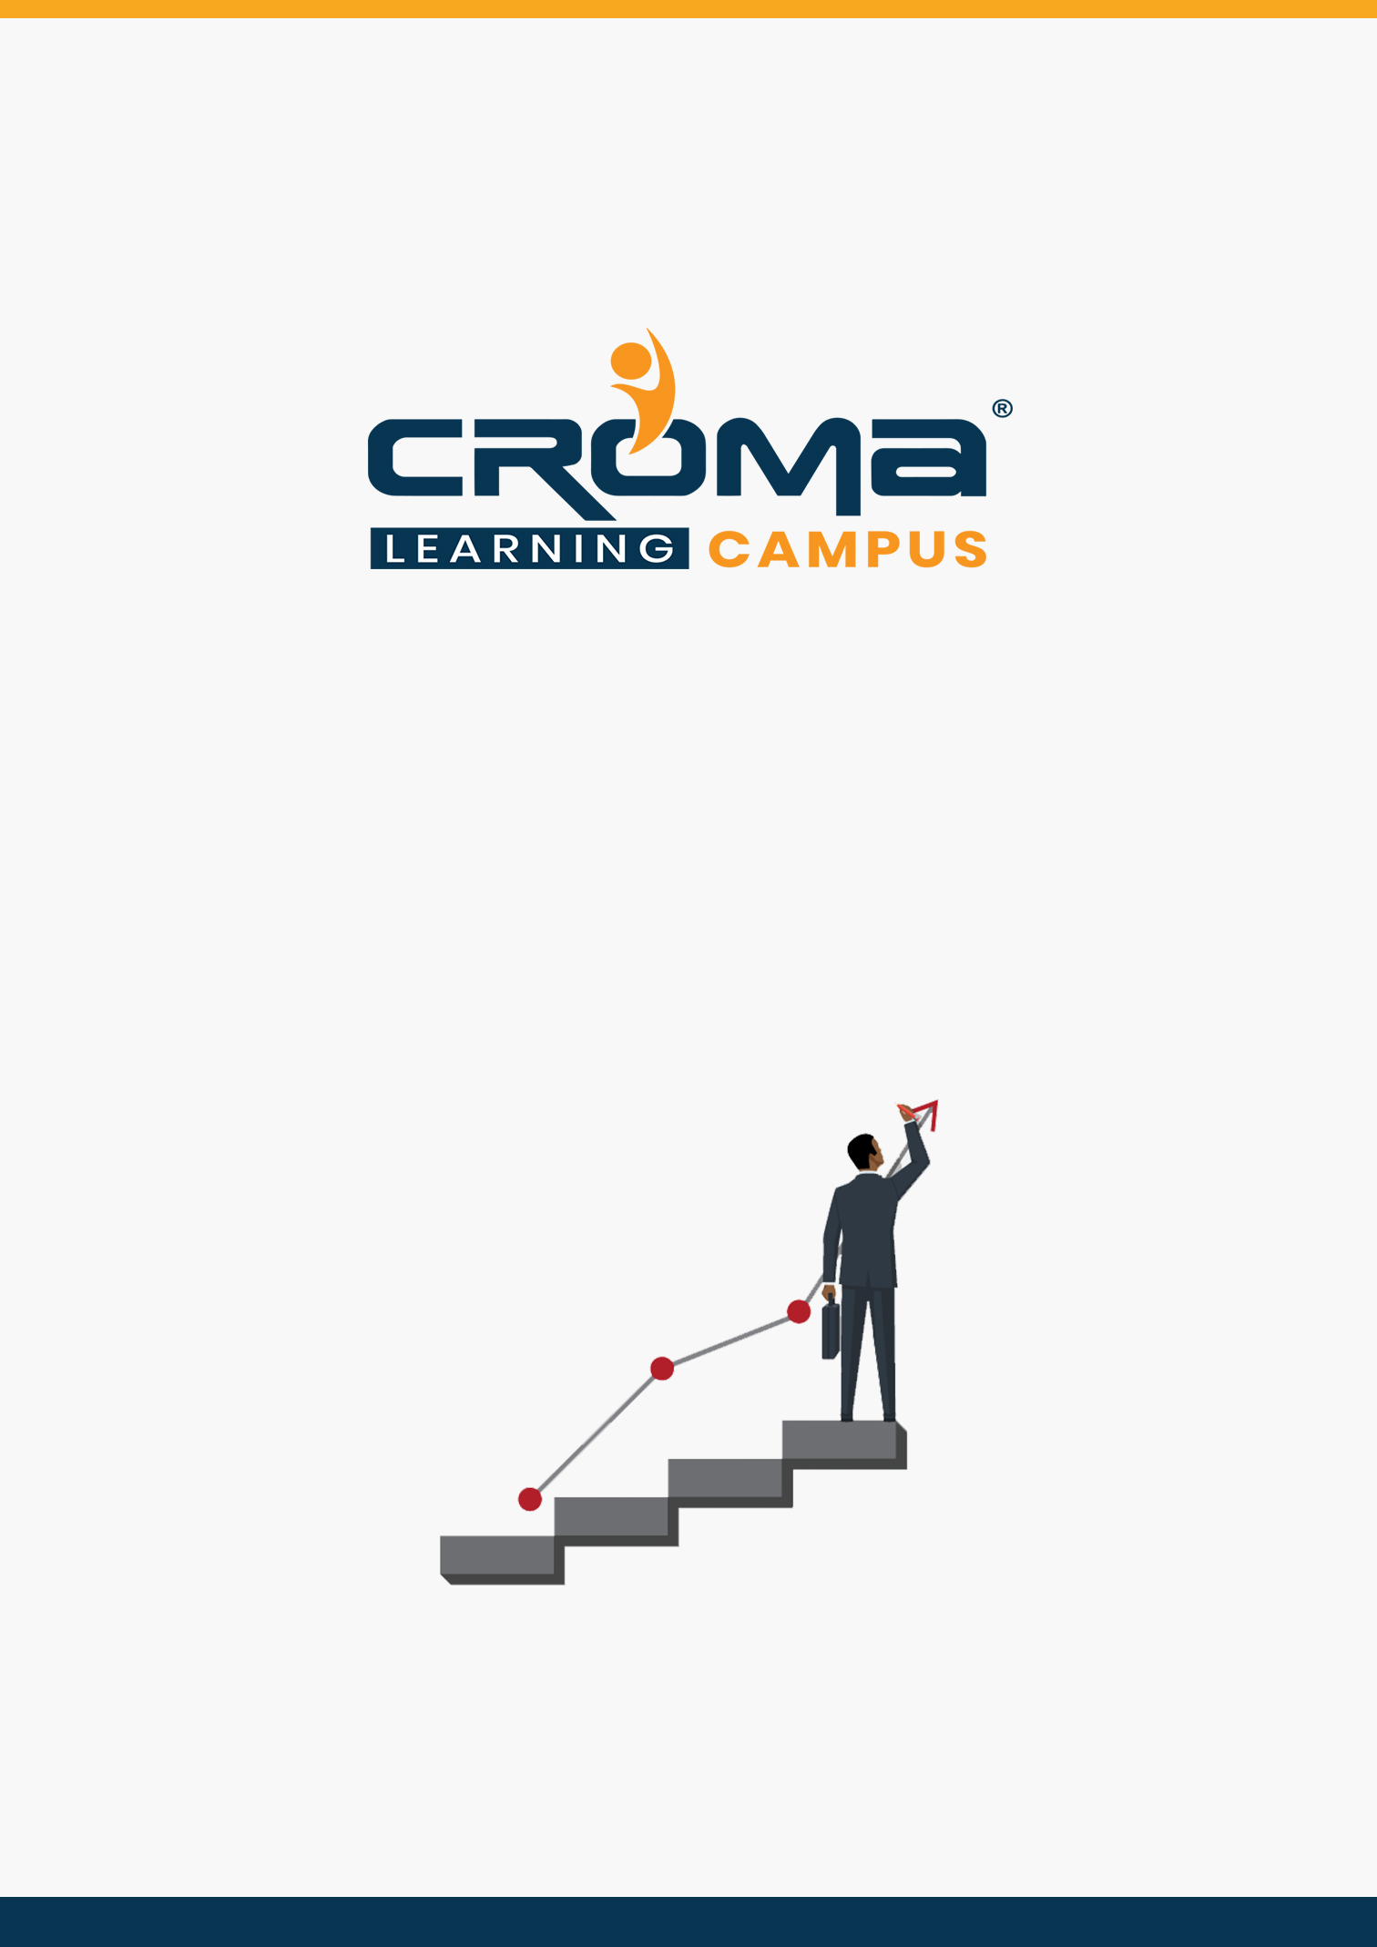

**Docker Training Curriculum**

**STRUCTURE**

**www.cromacampus.com | helpdesk@cromacampus.com | +91-120-4155255**

**Docker Training Curriculum**

*“Give an edge to your career with Docker Training Course at Croma Campus.”*

**About Croma Campus:**

Croma Campus Training & Development Private Limited is an education platform since 2010 providing rigorous industry-relevant programs designed and delivered in collaboration with world-class faculty and industry.

* Hands-On Live Projects
* Simulation Test Papers
* Industry Cases Studies
* 61,640+ Satisfied Learners
* 140+ Training Courses
* 100% Certification Passing Rate
* Live Instructor Classroom / Online Training
* 100% Placement Assistance

**Course Objectives:**

* Understand the fundamentals of Containerization
* Set up the Docker Engine
* Deploy a Docker Container
* Manage Docker Containers
* Configure Logging Drivers
* Create Docker images using a Docker-file
* Store and share Docker images using Registry
* Utilize various storage strategies
* Compose multi-container applications
* Deploy a Swarm cluster
* Configure network drivers
* Secure the Docker Daemon
* Set up Docker Enterprise (Docker EE)
* Configure UCP and DTR for Docker EE
* Deploy Kubernetes Pods and Deployments
* Use Kubernetes Services for application discovery
* Use Persistent Volumes for storage.

**Course Description:**

The Docker training course gives you a solid foundation for the official “***Docker Certified Associate exam***”. The training program is designed from the ground up to teach new learners about the intricacies of the Docker containerization technology.

The course starts with the fundamentals of Docker and works up to more advanced topics such as Docker Compose, Docker Swarm, handling Network and Security, working with UCP (Universal Control Panel) and DTR (Docker Trusted Registry) in Docker Enterprise.

Additionally, this course also introduces you to different storage strategies such as Volumes, Bind Mounts, and tmpfs mount, which will further help you optimize your containerized application’s execution. You will learn to use Docker Registry to manage and keep track of your custom Docker images, and finally, learn the basics of Kubernetes Container Orchestration tool with the Docker engine.

**Croma Campus Training Program Deliverables:**

* **Session Recordings** - Original Class Room Voice & Video Recording
* **Training Material** - Soft Copy Handbooks
* **Assignments** | 25+ Hands-on Exercises
* **Test Papers** - We provide **Practice Test** as part of our course to help you prepare for the actual certification exam.
* **Live Case Studies**
* **Live Projects** - Hands-on exercises and Project work. You will work on real time industry-oriented projects and assignments for each module to practice.
* **Key focus on Hands-on exercises and Project work**. You will work on real time industry-oriented projects.
* Faculty with more than **10+ Years of Experience** in the Industry.
* **Technical Resume Designing & Job Assistance:** With more than 100+ Clients across the Globe and we help learners to get a good job in their respective field. We also help learners with resume preparation.
* **Interview Q&A**
* **About Croma Campus Training Certificate:** Croma Campus will provide you with an industry-recognized (Certified by **ISO 9001:2015** & **E-Cell IIT Jodhpur**) course completion certificate which has lifelong validity.
* **How I Unlock my Croma Campus Certificate:** Attend Complete Batch & Submit at least One Completed Project.

**Course Content:**

**Module 1: Containerization Overview**

* Containerization
* History of Containers
* Namespaces and C Groups
* Containers vs Virtual Machines
* Types of Containers
* Introduction to Docker
* Docker Architecture
* Container Lifecycle
* Docker CE vs Docker EE

**Module 2: The Docker Engine**

* Docker Engine
  + Setting up Docker Engine
  + Upgrading Docker Engine
* Setting up logging drivers in Docker
* Configuring Logging Drivers
* Docker Terminology
* Port Binding
* Detached vs Foreground Mode
* Starting Containers in different modes
* Docker CLI Commands
* Docker Exec Commands
* Restart Policy in Docker
* Removing Containers

**Module 3: Image Management & Registry**

* Docker-file
* Write a Docker-file to create an Image
* Docker-file Instructions
* Docker Registry
* Configuring Local Registry
* Build Context
* Docker Image Tags
* Setting up Docker Hub
* Removing Images from the Registry

**Module 4: Storage in Docker**

* Docker Storage
* Types of Persistent Storage
* Volumes
* Bind Mounts
* TMPFs Mount
* Storage Drivers
* Device Mapper
* Docker Clean Up

**Module 5: Orchestration in Docker**

* Docker Compose
* Deploy a Multi-container Application using Compose
* Docker Swarm
* Running Docker in Swarm mode
* Docker Service
* Deploying a Service in Swarm
* Service Placement
* Scale Services
* Rolling Update and Rollback
* Docker Stack

**Module 6: Networking and Security**

* Docker Networking
* Network Drivers
* Bridge Network
* Overlay Network
* Host and Macvlan
* Docker Security
* Docker Content Trust
* Securing the Docker Daemon
* Create and use a User-defined Bridge Network
* Create and use an Overlay Network
* Use Host and Macvlan Network
* Configure Docker to use External DNS
* Signing images using DCT

**Module 7: Docker EE and Monitoring**

* Docker Enterprise
* Universal Control Plane (UCP)
* UCP Architecture
* Access Control in UCP
* Docker Trusted Registry (DTR)
* Monitoring using Prometheus

**Module 8: Docker with Kubernetes**

* Kubernetes Core Concepts
* Setup Kubernetes cluster using GKE
* Kubernetes Common Commands
* Pods - Deploy a Pod
* Deployments - Use a Deployment for pod management
* Labels, Selectors, and Annotations
* Services - Deploy different Services
* Persistent Volumes and Persistent Volume Claims
* Use Persistent Storage in Kubernetes
* Storage Classes
* Use Storage Classes

**Module 9: Docker with Microservices**

* What are Microservices?
* Understanding Microservices and Docket together
* Using Docker for Microservices
* Advantages of using Docker for Microservices
* Design Microservices Architecture with Docker Containers
* Extending the Architecture of a Microservices-Based App with Docker

**Module 10: Placement Guide**

* Tips to clear an Interview
* Common Interview questions and answers
* Docker Interview Questions and Answers
* Resume Building Guide
* Career roadmap and certifications
* Attempt for related Global Certification Exam
* Start applying for Jobs